Version 2.0
July 19, 2021
7/19/2021
penguin random house, llc

CSV Implementation Guide
for direct Market use

CSV Implementation Guide
Revisions to the Implementation Guide are as follows:
Revision 1.0: 5-21-2021
- Created implementation guide in order to outline data values that will be used by our proprietary distribution system in addition to new delivery timelines
Revision 2.0: 7-19-2021
- Addition of “MaxOrderQuantity” field to the CSV file, and associated definitions
- Creation and implementation of Weekly Catalog Change files (“Delta” files) in addition to Monthly Catalog Full files
- Addition of inactive title data (“Withdraw” data) to both Monthly and Weekly CSV files
- Adjustment of timeline for available data in the General Information schedule section, from 10:00pm EST to 12:05am EST
- Addition of Sample CSV files for testing purposes
- New “How To” Helpful Tips section added, including step-by-step instructions for safely importing and opening a CSV file in Excel
- Updated Direct Market specific email address for CSV and data issues added (dmdistrosupport@penguinrandomhouse.com)

CSV Data Files Overview

General Information
This implementation guide includes the specific data elements and corresponding values that Penguin Random House provides in CSV files intended for use by the Direct Market. The CSV data files can be accessed via the Catalog page once you log in to your selfservice.penguinrandomhouse.biz account. There will be a separate full CSV file posted per Catalog Month, in addition to weekly delta CSV files posted each week

Schedule
Penguin Random House provides metadata feeds according to the following schedule:
- Monthly Catalog CSV files are updated at 12:05 a.m. EST each night, with the most up-to-date data elements for all items in that month’s solicitation catalog.
  - Penguin Random House will continue to update data for catalogs dated 2 months prior to the current calendar month, in addition to the current month and newest future month’s solicitation catalog data.
  - For example, as of July 23, 2021, PRH will update the August, July, June, and May 2021 catalogs each night.
- Weekly Catalog Delta CSV files are updated at 12:05am EST on Fridays each week. These files are identical in structure to the Monthly Catalog CSV file but only include items in that month’s solicitation catalog that have experienced a data change since the prior Friday. A separate Weekly Catalog Delta CSV file will be created for each solicitation catalog month.
  - For example, as of July 23, 2021, PRH will create separate weekly catalog delta csv files for the August, July, June, and May 2021 catalogs every Friday at midnight.

On occasion, off-cycle immediate updates may be transmitted by Penguin Random House and will be present within the catalog data file.

CSV DATA FILE
- The CSV file is UTF-8 encoded.
- The file will contain blanks and will not contain any “0” placeholder values. If there is no value for a data field, an empty (null/blank) string will be present and not a “0” value. If a “0” is present in a data field, it is an intentional value.
- The header row will always be present in each CSV file; each column header will not contain any spaces (for example, Cover Available will be represented in the header row as CoverAvailable).
- Note that if attempting to use Excel in order to review the CSV data file, proper steps must be taken to import the file into Excel in order to preserve key data fields (Main Identifier, UPC, ISBN, Order Requirement, Order Requirement UPC). PRH strongly suggests loading and transforming these fields as text within Excel in order to ensure data integrity.
- Any descriptive data fields (Description, Contributor Bio) are stripped of HTML, and double quotes have been escaped to preserve data integrity.
- All dates within the file should be displayed as MM/DD/YYYY. Note that if attempting to use Excel in order to review the CSV data file, leading zeroes before a date (for example, 05/01/2021) may be omitted by Excel formatting (5/1/2021).
- Withdraw Notifications occur when an item may become postponed, canceled, or otherwise made inactive and withdrawn from active solicitation. In these cases, the Monthly Catalog CSV file and the appropriate Delta Catalog CSV file will include the relevant information (Sales Status Code and Sales Status fields will reflect the appropriate inactive status, e.g. PP – Postponed).

Technical Support
For technical assistance with the Penguin Random House CSV data file, please email dmdistrosupport@penguinrandomhouse.com.

CSV Data File Elements

Data Elements and Values Included

Main Identifier
Column Position | Data Element
1 | MainIdentifier
The MainIdentifier field will always be the item's UPC or ISBN. A title may only have a UPC-17 or an ISBN. Always refer to this identifier when making product updates or placing orders.

Example
75960608857704611

UPC
Column Position | Data Element
2 | UPC

The UPC field provides the 12-digit Universal Product Code and 5-digit supplements for all items which carry a UPC.

Example
75960608857704611

ISBN
Column Position | Data Element
3 | ISBN
The ISBN field provides the 13-digit International Standard Book Number for all items which carry an ISBN.

Example
9781302920494

Title
Column Position | Data Element
4 | Title
The Title field encompasses the full title of an item. This field may contain relevant information such as series number and variant information, where applicable.

Example
AVENGERS 46 MOMOKO MARVEL ANIME VARIANT

Subtitle
Column Position | Data Element
5 | Subtitle
The Subtitle field is a secondary or explanatory title, often printed on the cover of an item.

Example
The Encyclopedia of Starfleet Ships

Publisher name
Column Position | Data Element
6 | PublisherName
The PublisherName field displays the name of the publisher or division that is publishing the item.

Example
Marvel

imprint name
Column Position | Data Element
7 | ImprintName
The ImprintName field displays the name of the imprint or brand that is publishing the item.

Example
Marvel Universe

Format Code, Format Description
Column Position | Data Element
8 | FormatCode
9 | FormatDescription
The FormatCode field is a proprietary alpha code that corresponds to the specific format of the item. The FormatName field is a descriptive translation of the proprietary FormatCode field.
Possible Values. FormatCode values and corresponding FormatDescription values provided by Penguin Random House are below.
Format Code | Format Description |  | Format Code | Format Description
CB | Comic Book |  | SK | Stickers
TR | Trade Paperback |  | TA | Tattoos
MM | Mass Market Paperback |  | TC | Trading Cards
MX | Mass Max Paperback |  | PS | Poster
PR | Mass Premium Paperback |  | GC | Graphic Comic Box
HC | Hardcover |  | NO | Novelty Item
HCSL | Hardcover Slip Cased |  | NT | Non-Traditional
BX | Boxed Set |  | BE | Spiral Bound
BXBR | Board Boxed Set |  | BF | Pamphlet
BXDG | Digest Boxed Set |  | BI | Rag Book
BXHC | Hardcover Boxed Set |  | BJ | Bath Book
BXMM | Mass Market Boxed Set |  | BK | Novelty Book
BXMX | Mass Max Boxed Set |  | CC | Sheet map, flat
BXPF | Diary Boxed Set |  | CG | General Merchandise
BXPR | Mass Premium Boxed Set |  | DE | Game Cartridge
BXTR | Trade Paper Boxed Set |  | DW | Tableware
CL | Coloring Book |  | FM | Other apparel
BR | Board Book |  | FZ | Novelty Book
LF | Lift-the-Flap |  | JW | Jewelry
PU | Pop-up Book |  | LB | Tote bag
SM | Scented Book |  | PA | Notebook
TF | Touch & Feel |  | PC | Calendar
CD | Audio CD |  | PD | Cards
CS | Audio Cassette |  | PF | Diary
DG | Digest Paperback |  | PK | Poster
MG | Mixed Media |  | ST | Sticker Book
XA | Trade-only Material |  | WW | Mixed Media
BM | Bookmark |  | ZA | General Merchandise
CA | Calendar |  | ZC | Soft Toy
CT | Catalog |  | ZD | Toy
CV | Cover |  | ZE | Board Game
LG | Lithograph |  | VI | Video
PT | Postcard

Sales Status Code, Sales Status
Column Position | Data Element
10 | SalesStatusCode
11 | SalesStatus
The SalesStatusCode field includes 2-character codes indicating the publication status of the item. The SalesStatus field includes the descriptive translation of the publication status of the item.
Possible Values. SalesStatusCode values and corresponding SalesStatus values provided by Penguin Random House are below.
Sales Status Code | Sales Status
IP | Active
CA | Cancelled
OP | Out of Print
OS | Inactive
PP | Postponed
RM | Remaindered
XD | Not Our Product

Series Name
Column Position | Data Element
12 | SeriesName
The SeriesName field provides the name of a series, if the item is a part of a series.

Example
AVENGERS

Series Code
Column Position | Data Element
13 | SeriesCode
The SeriesCode field is an alphanumeric code associated with a series, if the item is part of a series. Note that this field will match previous numeric Diamond Series Codes for any Marvel series exclusively distributed by Diamond previously, however any new series distributed by Penguin Random House will carry PRH-proprietary alphanumeric series codes.

Example
PRH Example Series Code: Q1C
Diamond Example Series Code: 145197

Series Number
Column Position | Data Element
14 | SeriesNumber
The SeriesNumber field displays the issue or volume number of the item, if it is part of a numbered series.

Example
46

Comic Type
Column Position | Data Element
15 | ComicType
The ComicType field discloses information specific to the publication cadence or type of the item.
Possible Values. ComicType values provided by Penguin Random House are below.
Comic Type | Description
ONGOING | Ongoing comic book series (not part of a limited series or crossover event, for example). This could be on a weekly or monthly cadence.
TWICE MONTHLY | Twice Monthly comic book series (not part of a limited series or crossover event, for example).
LIMITED | Limited comic book series with a maximum number of planned issues in the series.
ONE-SHOT | One-Shot comic book (could be part of a limited event, but not part of the sequential numbered series).

Price USD and Price CAD
Column Position | Data Element
16 | PriceUSD
17 | PriceCAD
The PriceUSD field includes the suggested retail price in US dollars. The PriceCAD field includes the suggested retail price in Canadian dollars. Note that this field will not include a dollar sign ($).

Example
4.99

BISAC and BISAC Description
Column Position | Data Element
18 | BISAC1
19 | BISAC1Description
20 | BISAC2
21 | BISAC2Description
22 | BISAC3
23 | BISAC3Description
The BISAC1 field denotes the first 9-character alphanumeric BISAC code associated with the item. The Book Industry Standards and Communications (BISAC) Subject Heading list is an industry-approved list of subject descriptors, intended to help retailers and data providers standardize genre and subject classification.
The BISAC1Description field provides the descriptive translation of the corresponding BISAC1 subject code.
Up to 3 BISAC subject codes and BISAC descriptions may be provided for any Penguin Random House distributed item and are ordered in terms of importance from 1-3.

Example
BISAC1 | BISAC1Description | BISAC2 | BISAC2Description | BISAC3 | BISAC3Description
CGN004290 | Comics & Graphic Novels - Manga - Supernatural | CGN004280 | Comics & Graphic Novels - Manga - School Life | CGN004160 | Comics & Graphic Novels - Manga - Media Tie-In

Language
Column Position | Data Element
24 | Language
The Language field provides a 3-character code that provides information about the language of the item.
Possible Values. Language values provided by Penguin Random House are below.
grc | Ancient Greek |  | ita | Italian
ara | Arabic |  | jpn | Japanese
baq | Basque |  | kor | Korean
ben | Bengali |  | lat | Latin
cat | Catalan |  | mul | Multiple
chr | Cherokee |  | qls | Neutral Latin American Spanish
chi | Chinese |  | nor | Norwegian
hrv | Croatian |  | arc | Imperial Aramaic (700-300 BCE)
cze | Czech |  | ang | Old English
dan | Danish |  | per | Persian (Farsi)
dut | Dutch; Flemish |  | pol | Polish
dum | Dutch; Middle |  | por | Portuguese
eng | English |  | rus | Russian
est | Estonian |  | sam | Samaritan Aramaic
fre | French |  | san | Sanskrit
ger | German |  | slv | Slovenian
gre | Greek, Modern (1453-) |  | spa | Spanish
heb | Hebrew |  | swe | Swedish
hin | Hindi |  | tam | Tamil
hun | Hungarian |  | tur | Turkish
ind | Indonesian |  | yid | Yiddish
gle | Irish

Age Range
Column Position | Data Element
25 | AgeRange
The AgeRange field is a four-character alphanumeric range of ages that apply to the target audience of the item.
Possible Values. AgeRange values and the corresponding descriptions provided by Penguin Random House are below.
AgeRange | Description |  | AgeRange | Description
0002 | 0-2 years |  | 0709 | 7-9 years
0003 | 0-3 years |  | 0710 | 7-10 years
0103 | 1-3 years |  | 0711 | 7-11 years
0204 | 2-4 years |  | 07UP | 7 and up
0205 | 2-5 years |  | 0809 | 8-9 years
0305 | 3-5 years |  | 0810 | 8-10 years
0306 | 3-6 years |  | 0811 | 8-11 years
0307 | 3-7 years |  | 0812 | 8-12 years
0406 | 4-6 years |  | 0912 | 9-12 years
0407 | 4-7 years |  | 1014 | 10-14 years
0408 | 4-8 years |  | 1017 | 10-17 years
0506 | 5-6 years |  | 10UP | 10 and up
0507 | 5-7 years |  | 1214 | 12-14 years
0508 | 5-8 years |  | 12UP | 12 and up
0509 | 5-9 years |  | 1317 | 13-17 years
0607 | 6-7 years |  | 13UP | 13 and up
0608 | 6-8 years |  | 14UP | 14 and up
0609 | 6-9 years |  | 16UP | 16 and up
0708 | 7-8 years |  | 18UP | 18 and up

Media Rating
Column Position | Data Element
26 | MediaRating
The MediaRating field discloses the actual media rating value for the item.
Possible Values. MediaRating values provided by Penguin Random House are below.
Media Rating | Description
Explicit Content | Appropriate for readers age 18 and older.
Mature | Appropriate for readers age 17 and older. May contain intense violence, extensive profanity, nudity, sexual themes and other content suitable only for older readers.
Parental Advisory | Appropriate for 15 and up. Similar to T+, but featuring more mature themes and/or more graphic imagery. Recommended for teen and adult readers.
Parental AdvisorySLC | Same as Parental Advisory, but contains Strong Language Content.
Rated T+ | Appropriate for readers age 15 and older. May contain moderate violence, mild profanity, graphic imagery and/or suggestive themes.
Rated T | Appropriate for readers age 12 and older. May contain mild violence, language and/or suggestive themes.
No Rating | No media rating for this item.
[null/blank] | No media rating for this item.

FOC Date
Column Position | Data Element
27 | FOCDate
The FOCDate field provides the Final Order Cutoff date for the item, expressed in MM/DD/YYYY.

Example
06/14/2021

On Sale Date
Column Position | Data Element
28 | OnSaleDate
The OnSaleDate field provides the expected On Sale Date/In-Store Date for the item, expressed in MM/DD/YYYY.

Example
07/07/2021

Catalog Date
Column Position | Data Element
29 | CatalogDate
The CatalogDate field corresponds to the applicable solicitation catalog in which the item appears, expressed in MM/DD/YYYY.

Example
05/01/2021

Relisted
Column Position | Data Element
30 | Relisted
The Relisted field is a single value field. If a Y is present, it denotes that the item has appeared in a previous catalog and is available to be ordered again. (All other instances will display a null.) Please note that Relisted items are different from Reissued items (that were solicited in a previous catalog but were canceled before shipping).

Example
Y

Recatalog date
Column Position | Data Element
31 | RecatalogDate
The RecatalogDate field corresponds to the date when the item was relisted, expressed in MM/DD/YYYY.

Example
05/01/2021

Reissue catalog date
Column Position | Data Element
32 | ReissueCatalogDate
The ReissueCatalogDate field corresponds to the date when the item was reissued, expressed in MM/DD/YYYY.

Example
05/01/2021

Reissue
Column Position | Data Element
33 | Relisted
The Reiussue field is a single value field. If a Y is present, it denotes that the item was solicited in a previous catalog but was canceled before shipping, but now is available as a reissue. (All other instances will display a null.)

Example
Y

Variant Type
Column Position | Data Element
34 | VariantType
The VariantType field is a text field that denotes the type of variant the item is, if applicable.
Possible Values. VariantType values provided by Penguin Random House are below.
Item Type | Description
Primary Title | This could be either the primary copy of an issue OR the primary reprint of an issue, which will have a separate UPC but could still be in the title family.
Variant Title | Any title with a variant cover.
Party Variant | Promotional opportunity offered by some publishers several times a year to have a launch party for particular issues. The Party Variant has its own cover and will be linked to a number of promotional items, some of which are provided for free upon ordering the Party Variant and some of which are available for purchase once you have ordered the party variant.
Party Sketch Variant | A version of the party variant that uses the black and white sketch of the party variant cover for its cover.
Promotional Item | Marvel has a variety of promotional items. Most of these are provided to retailers on a monthly schedule with quantities determined by the size of the retailer. They will often also be available for sale to any retailer who wants to purchase more than their usual allotment.
Retailer Variant | Variant available exclusively at a certain retailer.
Non-Book Item | To Be Confirmed

Order Requirement and Order Requirement UPC
Column Position | Data Element
35 | OrderRequirement
36 | OrderRequirementUPC
The OrderRequirement field is a text field that denotes the ordering requirement, if any, to purchase the item. The OrderRequirementUPC field is a numeric field that should be used in conjunction with OrderRequirement.
If a UPC is present in this field, it represents the UPC that must be ordered in order to meet the corresponding OrderRequirement for the item.
Possible Values. OrderRequirement values provided by Penguin Random House are below.
OrderRequirement | Description
Order All | You may order as many copies of this cover as you want
1:n | You may order 1 variant for every n copies you purchase between the combined total of the item’s covers, excluding ratio variants

Example
OrderRequirement | OrderRequirementUPC
1:50 | 75960608857704611
In the example above, you may order 1 variant for every 50 copies you purchase of the listed OrderRequirementUPC
OrderRequirement | OrderRequirementUPC
1:25
In the example above, you may order 1 variant for every 25 copies you purchase between the combined total of the item’s covers, excluding ratio variants.

Writer
Column Position | Data Element
37 | Writer
The Writer field identifies the primary creator responsible for authoring/writing the item. Please note that only 1 contributor will appear in this field, displayed as FIRST LAST name.

Example
Jason Aaron

Artist
Column Position | Data Element
38 | Artist
The Artist field identifies the primary creator responsible for illustrating the item. Please note that only 1 contributor will appear in this field, displayed as FIRST LAST name.

Example
Javier Garron

Cover Artist
Column Position | Data Element
39 | CoverArtist
The CoverArtist field identifies the primary creator responsible for illustrating the cover of the item. Please note that only 1 contributor will appear in this field, displayed as FIRST LAST name.

Example
Peach Momoko

Colorist
Column Position | Data Element
40 | Colorist
The Colorist field identifies the primary creator responsible for coloring the item. Please note that only 1 contributor will appear in this field, displayed as FIRST LAST name.

Example
Espen Grundetjern

Inker
Column Position | Data Element
41 | Inker
The Inker field identifies the primary creator responsible for inking the item. Please note that only 1 contributor will appear in this field, displayed as FIRST LAST name.

Example
Ariana Maher

Colorist or Inker
Column Position | Data Element
42 | ColoristOrInker
The ColoristOrInker field identifies the primary creator responsible for either coloring or inking the item. Please note that only 1 contributor will appear in this field, displayed as FIRST LAST name.

Example
Heather Breckel

Contributor
Column Position | Data Element
43 | Contributor
The Contributor field identifies the any other primary creator responsible for some other contribution to the item. Please note that only 1 contributor will appear in this field, displayed as FIRST LAST name.

Example
Valeria Lopez

All Contributors
Column Position | Data Element
44 | AllContributors
The AllContributors field is a descriptive, concatenated field that lists all Writers (W), Artists (A), CoverArtists (CA), Colorists (C), Inkers (I), ColoristorInkers (CI), and Contributors (CT) associated with the item. If there is more than one contributor per role, all contributors will be displayed as FIRST LAST name and separated by a semicolon.

Example
(W) Jason Aaron; Kieron Gillen (A) Javier Garron (CA) Peach Momoko (CT) Heather Breckel

Page Count
Column Position | Data Element
45 | PageCount
The PageCount field displays the page count of the publication.

Example
40

Carton Quantity
Column Position | Data Element
46 | CartonQuantity
The CartonQuantity field displays the number of individual units contained in a single carton.

Example
180

Width and Height
Column Position | Data Element
47 | Width
48 | Height
The Width field displays the width of the item in inches, rounded to the fourth decimal place. The Height field displays the height of the item in inches, rounded to the fourth decimal place.

Example
Width | Height
6.625 | 10.1875

Description
Column Position | Data Element
49 | Description
The Description field displays the full description associated with the item. Note that this text will not contain any HTML formatting, and double quotes will be escaped to maintain file integrity.

Example
WORLD WAR SHE-HULK! After the shocking events of Enter the Phoenix, the Earth has become more fractured and volatile than ever, especially for the Avengers. Once She-Hulk is declared a global menace, Russia's mightiest heroes, the Winter Guard, are tasked with bringing Jen to justice, to face a fate no Hulk could hope to endure. Rated T+

Contributor Bio
Column Position | Data Element
50 | ContributorBio
The ContributorBio field displays the full biography associated with the contributor(s) of the item. Note that this text will not contain any HTML formatting, and double quotes will be properly escaped to maintain file integrity.

Example
Born in 1981, NISIOISIN dropped out of Ritsumeikan University in Kyoto, to pursue a career in story-telling. Initially he had ambitions to be a comic artist, but he began to focus on his writing, eventually winning the 23rd Mephisto Prize, for Kubikiri Cycle (Del Rey) recognizing his talents as a mystery writer, at the age of 20. Since his debut in 2002 Nisio has penned more than 50 novels and a number of comics. And he has quickly become one of Japan's top selling author's in recent memory with more than 5 million units sold since 2009.

Sales Restrictions
Column Position | Data Element
51 | SalesRestrictions
The SalesRestrictions field displays the geographic territories where the item may be sold.
Possible Values. SalesRestrictions values provided by Penguin Random House are below.
SalesRestrictions | Description
World | The item may be sold throughout the world.
US/CAN (No Open Mkt) | The item may be sold in the US and Canada only.
US Only | The item may be sold in the US only.
World except Canada | The item may be sold throughout the world, except Canada.
Canada Only | The item may be sold in Canada only
Canada and Open Mkt | The item may be sold in Canada and Open Market territories only
US, Canada, Open Mkt | The item may be sold in the Us, Canada and any Open Market territories only.
US, CAN, OpnMkt (No EU) | The item may be sold in the US, Canada, and any Open Market territories aside from countries belonging to the European Union
World except UK | The item may be sold throughout the world except for the UK.
World except AU/NZ | The item may be sold throughout the world except for Australia and New Zealand
World except Opn Mkt | The item may be sold throughout the world except for any Open Market territories

Title Family
Column Position | Data Element
52 | TitleFamilyID
The TitleFamilyID field is a numeric code assigned to all related items for a given Title/Issue. While having unique UPCs or ISBNs, all primary covers, variant covers, and promotional items for a given title will have the same Title Family ID.

Example
702976

Cover Available
Column Position | Data Element
53 | CoverAvailable
The CoverAvailable field is a single-value field. If a Y is present, it denotes that the item has an available cover image. All other instances will display a blank, which means a cover image is not yet available.

Example
Y

Cover Color
Column Position | Data Element
54 | CoverColor
The CoverColor field denotes whether the front cover of the item is in color or black and white. If any color other than black, white, or gray appears on the cover, it will be considered a color cover. If the field is blank, it means a cover image is not yet available.
Possible Values. CoverColor values provided by Penguin Random House are below.
CoverColor | Description
black and white | Front cover of item only contains black, white, or gray colors
color | Front cover of item contains any color other than black, white, or gray

Cover Link
Column Position | Data Element
55 | CoverLink
The CoverLink field is a persistent URL that points to a high-resolution cover image for the item. If the field is blank, it means that a cover image is not yet available.
URL naming structure:
http://images.randomhouse.com/cover/d/MainIdentifier
Where MainIdentifier is the UPC or ISBN for the item

Example
http://images.randomhouse.com/cover/d/75960609508700111

Cover Update Date
Column Position | Data Element
56 | CoverUpdateDate
The CoverUpdateDate field indicates the last date the cover of the item was changed, expressed as MM/DD/YYYY. If the field is blank, it means that a cover image is not yet available.

Example
3/24/2021

Max Order Quantity
Column Position | Data Element
57 | MaxOrderQuantity
The MaxOrderQuantity field indicates the maximum orderable quantity, if any, of that item.
Possible Values. MaxOrderQuantity values provided by Penguin Random House are below.
MaxOrderQuantity | Description
No Limit | You may order as many copies of this item as you want
n | You may order up to a maximum of n copies of this item

Example
50
In the example above, you may order a maximum of 50 copies of this item.
No Limit
In the example above, you may order as many copies of this item as you want.

Diamond/Lunar Decoder

Column Position | Data Element | Corresponding Diamond Field | Corresonding Lunar Field
1 | MainIdentifier | UPC_NO; SHORT_ISBN | UPC; ISBN
2 | UPC | UPC_NO | UPC
3 | ISBN | SHORT_ISBN | ISBN
4 | Title | FULL_TITLE | Title
5 | Subtitle
6 | PublisherName | PUBLISHER | Publisher
7 | ImprintName |  | ImprintCode
8 | FormatCode |  | FormatCode
9 | FormatName | CATEGORY | ItemCategory; ProductCategory; CoverType
10 | SalesStatusCode
11 | SalesStatus
12 | SeriesName | MAIN_DESC | MainDesc
13 | SeriesCode | SERIES_CODE | SeriesCode
14 | SeriesNumber | ISSUE_NO ; VOLUME_TAG | IssueNumber
15 | ComicType | MAX_ISSUE | MaxIssue
16 | PriceUSD | PRICE | Retail
17 | PriceCAD
18 | BISAC1 | GENRE
19 | BISAC1Description | GENRE
20 | BISAC2 | GENRE
21 | BISAC2Description | GENRE
22 | BISAC3 | GENRE
23 | BISAC3Description | GENRE
24 | Language
25 | AgeRange
26 | MediaRating | MATURE, ADULT | Adult; Mature; Rating; T-Number
27 | FOCDate | PRNT_DATE | FOCDate
28 | OnSaleDate |  | InStoreDate
29 | CatalogDate | OFFERED_DATE
30 | Relisted | OA | O/A
31 | RecatalogDate
32 | ReissueCatalogDate
33 | Reissue | RESOL
34 | VariantType | VARIANT_DESC | VariantType
35 | OrderRequirement | ORDER_FORM_NOTES | OrderFormNotes
36 | OrderRequirementUPC | ORDER_FORM_NOTES
37 | Writer | WRITER | Writer
38 | Artist | ARTIST | Artist
39 | CoverArtist | COVER_ARTIST | CoverArtist
40 | Colorist | COLORIST | Color
41 | Inker
42 | Colorist or Inker
43 | Contributor
44 | AllContributors | CONTRIBUTORS [In Previews DB file]
45 | PageCount | PAGE | NumberOfPages
46 | CartonQuantity | BOX_PER_CASE | CartonCount
47 | Width | UNIT_WIDTH | TrimSize
48 | Height | UNIT_HEIGHT | TrimSize
49 | Description | DESCRIPTION [In Previews DB file] | Description
50 | ContributorBio
51 | SalesRestrictions
52 | TitleFamilyID
53 | CoverAvailable
54 | CoverColor
55 | CoverLink
56 | CoverUpdateDate
57 | MaxOrderQuantity

Sample CSV Files
All CSV files (Monthly Catalog CSV, Weekly Delta CSV) can be accessed on Penguin Random House’s self-service biz site. For sample CSV output data files, please use the links below.

Sample Monthly Catalog CSV File
Sample Weekly Delta CSV File

“How To” Helpful Tips
Data can be complicated. In order to safely load data into your systems, you may have several questions. Penguin Random House will continue to update this section of our documentation with helpful instructions and tips as they pertain to data.

How To (Safely) Open a CSV File in Excel
If you are using Microsoft Excel to review and manipulate data from PRH’s CSV Data File, we highly recommend following these import steps in order to prevent loss of information or truncation/rounding issues.
For example: Microsoft Excel cannot handle numbers with more than 15 digits per cell. When UPCs are entered as a number in a cell, Excel will store the first 15 digits but then replace any remaining digits with zeroes.
For example, this UPC…
MainIdentifier
75960609341000049
…may translate to the below if the file is not imported correctly.
MainIdentifier
7.59606E+16
MainIdentifier
75960609341000000

Other common issues you might run into if you haven’t imported the CSV safely into excel may include:
- OrderRequirement looks like a timestamp 1:05:01
- OrderRequirement looks like a decimal 0.111111111
- OrderRequirementUPC looks like 7.59606E+16 or 75960609341000000
- ISBN looks like 9.7813E+12
- Description or ContributorBio contain strange symbols like: LINKÂ is a bestselling Japanese writer best known for the mangaÂ
- And more…

In order to import the PRH CSV Data file safely into Excel, follow these steps:
- Open the Excel spreadsheet where you want to import the CSV data. (This can be a brand new spreadsheet in Excel, or an existing XLSX spreadsheet.) Click the Data tab.
- In the “Get Data” section, select From Text/CSV.
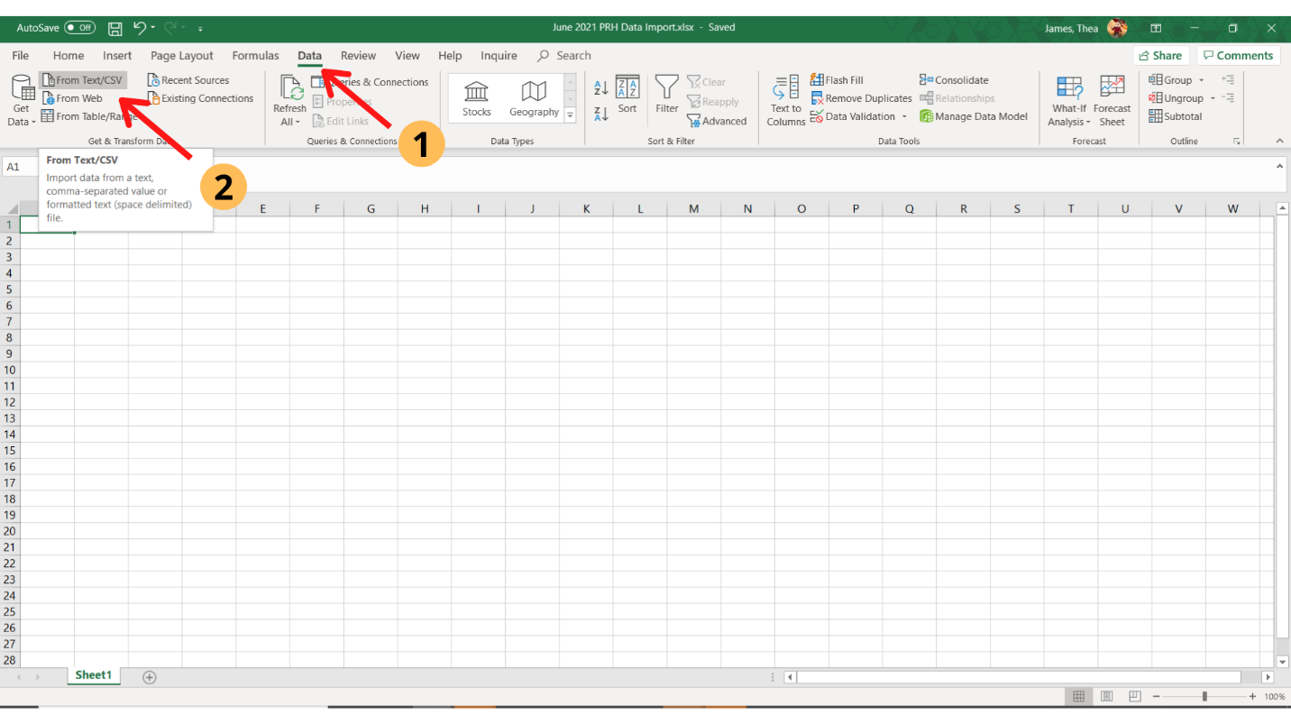
- Select the CSV file you are trying to import, and click Import.
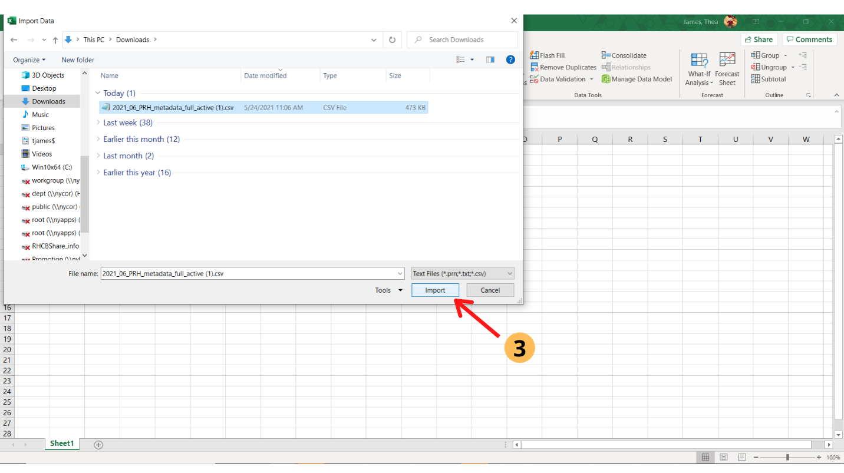
- You’ll see a screen that previews the CSV data. Make sure to select the following items from each dropdown menu:
  - File Origin: Unicode (UTF-8)
  - Delimiter: Comma
- Then, select Transform Data.
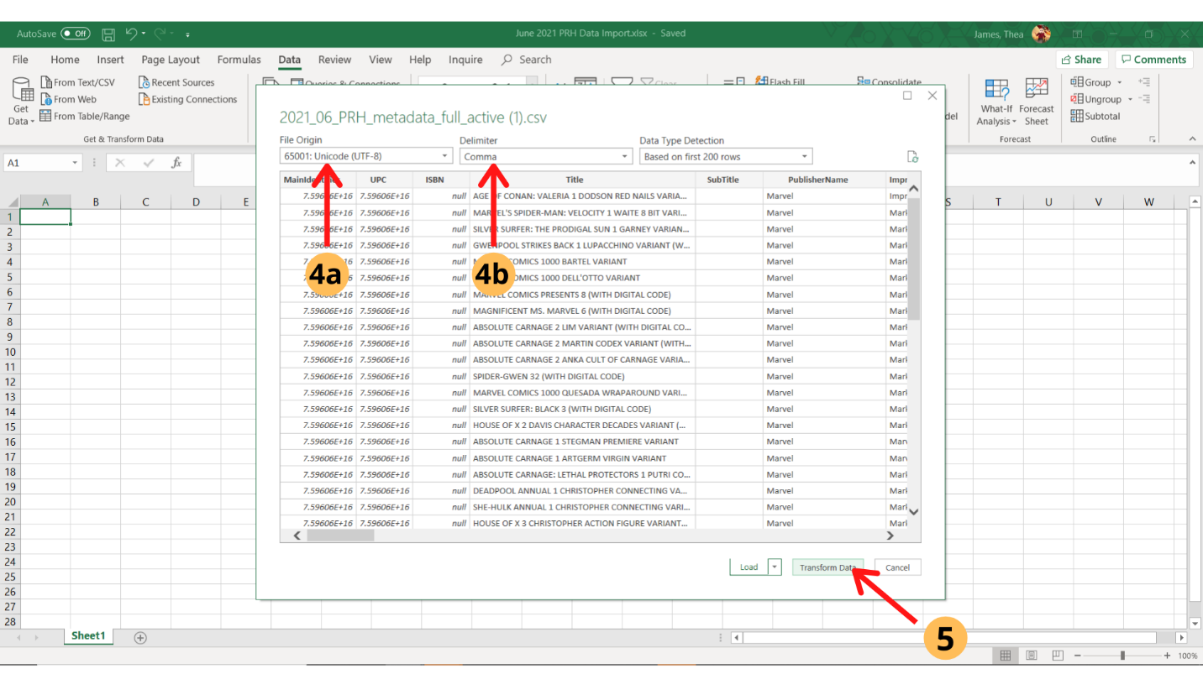

- The following columns will need to be transformed: MainIdentifier, UPC, ISBN, OrderRequirement, OrderRequirementUPC.
  - Starting with MainIdentifier, select Text from the formatting dropdown menu.
  - Then, select Replace Current. (You will see that all of your scientific notation UPCs now should have real UPC information on your preview.)
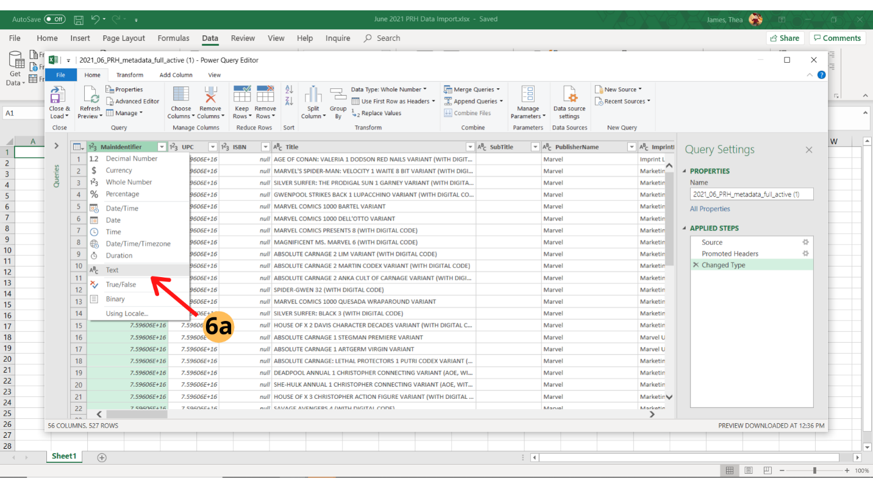
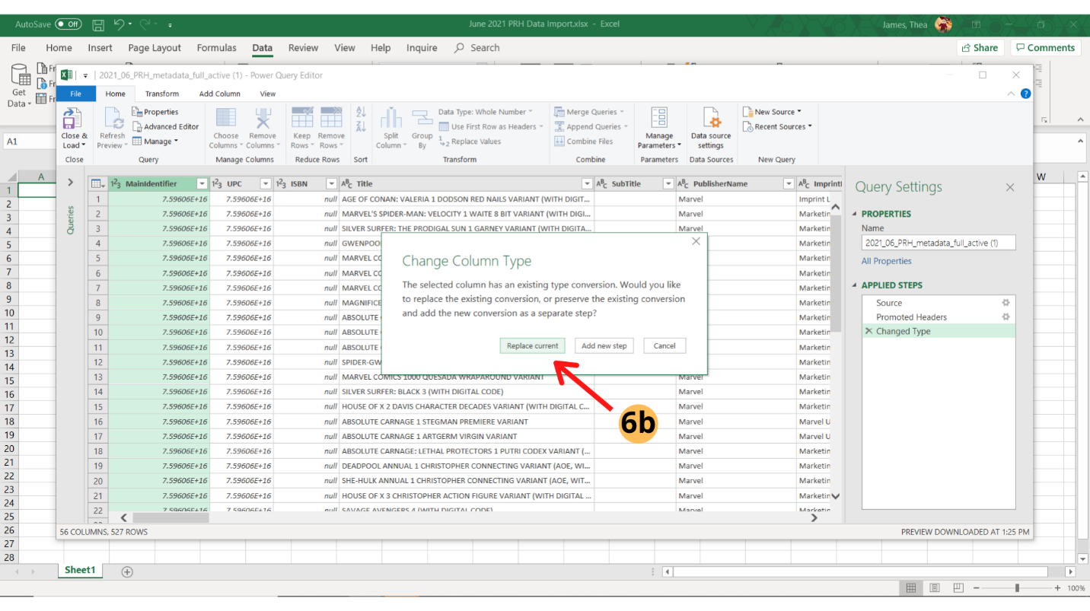
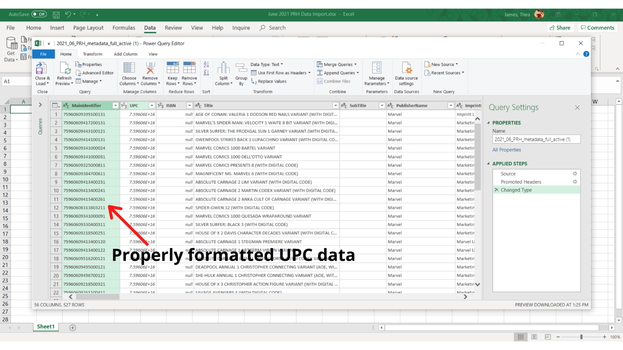
Pro Tip: If you’ve tried these steps and still see that your MainIdentifier column contains UPCs that look like scientific notation (7.59606E+16) or end in a string of zeroes (75960609341000000), you’ll need to close out the import query and try again.
- Repeat steps 6a and 6b for the following columns: UPC, ISBN, OrderRequirement, OrderRequirementUPC.
- Under the File menu, click Close and Load.
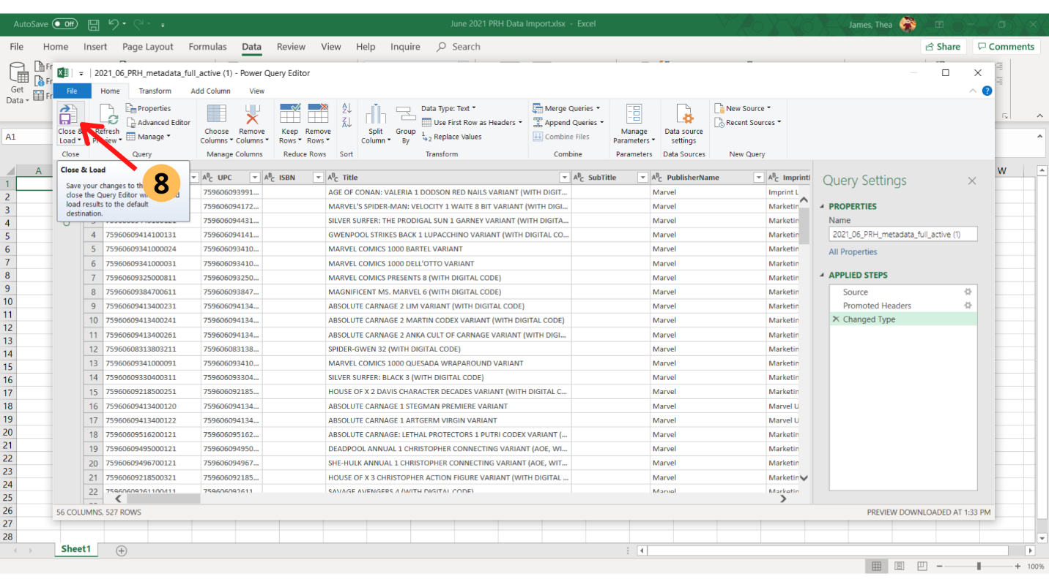
You should now have your properly formatted Excel import of the CSV Data File!

